VAT 222
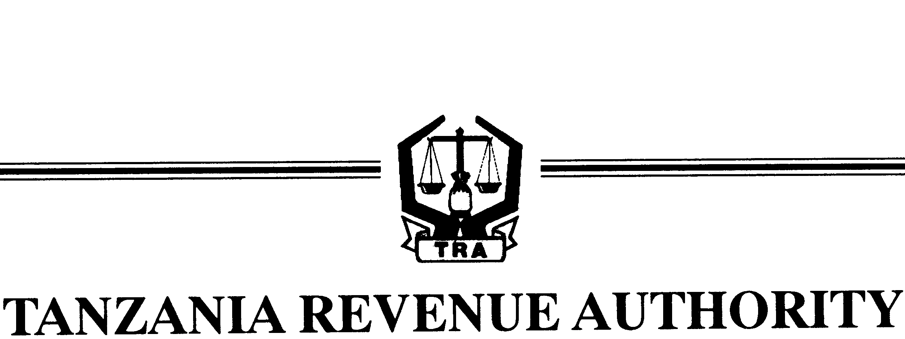

VALUE ADDED TAX FORM

Complete
In Quadruplicate

To: COMMISSIONER FOR DRD/LTD
P.O. BOX 1629 or P.O.BOX 9462,
DAR ES SALAAM.

APPLICATION FOR UTILIZATION OF VAT RELIEF GRANTED
TO DIPLOMATIC MISSIONS ON LOCAL SUPPLIES

*Delete which is not applicable:

1. NAME OF MISSIONS/CONSULATE/INTERNATIONAL ORGANISATION*

2. PARTICULARS OF THE PURCHASING OFFICER
(a) Name of the Officer ......................................................................................................
(b) Title of the Officer and Identity Card Number ..............................................................

3. DESCRIPTION OF GOODS:

NO. | TYPE OF GOODS | QUANTITY | VALUE IN T.SHS. | INTENDED USE

Signature of the Purchasing Officer ............................................................................

Date: ....................................

4. CONFIRMATION BY THE MISSION:

I hereby confirm that the above described goods are for official use of ......................................................................................................................................
......................................................................................................................................

........................................................ ........................................
HEAD OF MISSION Date

5. APPROVAL BY FOREIGN AFFAIRS
(a) Reference No.: ..........................................

(b) Request is APPROVED/NOT APPROVED*

............................................................... .........................................
PERMANENT SECRETARY Date

6. FOR OFFICIAL USE

VAT Head Office:

Request is APPROVED/NOT APPROVED*

...................................................................................... ................................................
COMMISSIONER FOR DRD/LTD Date

Distribution: Original - Commissioner for DRD/LTD
Duplicate - Permanent Secretary, Ministry of Foreign Affairs and International Co-operation.
Triplicate - Supplier of goods
Quadruplicate - Applicant.

